The dictionary definition of polymorphism refers to a principle in biology in which an organism or species can have many different forms or stages. This principle can also be applied to object-oriented programming and languages like the Java language.
Polymorphism is categorized into two types:

- Static Polymorphism/Compile time binding
- Dynamic Polymorphism/Run Time binding
Example 1: Static Polymorphism
class Person {
public void disp() {
System.out.println("The Values are: ");
}
public void disp(String name) {
System.out.println("Hello " + name);
}
public void disp(int age) {
System.out.println("The age is: " + age);
}
public void disp(String name, int age) {
System.out.println("Hello " + name + ", Age: " + age);
}
}
public class Test {
public static void main(String[] args) {
Person person = new Person();
person.disp();
person.disp("Komal", 25);
}
}
Subclasses of a class can define their own unique behaviors and yet share some of the same functionality of the parent class.
The Java virtual machine (JVM) calls the appropriate method for the object that is referred to in each variable. It does not call the method that is defined by the variable's type. This behavior is referred to as virtual method invocation and demonstrates an aspect of the important polymorphism features in the Java language.
Polymorphism in simple words means to have multiple forms of a single entity.
Example 1:
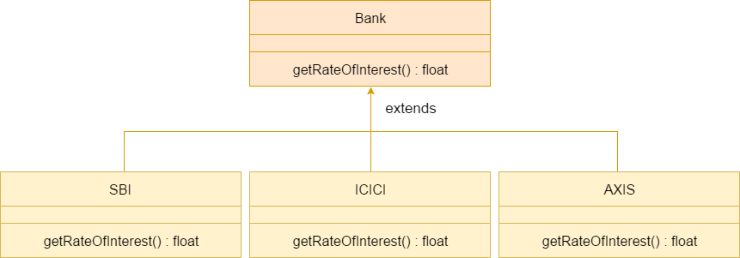
class Bank {
float getRateOfInterest() {
return 0;
}
}
class SBI extends Bank {
float getRateOfInterest() {
return 8.4f;
}
}
class ICICI extends Bank {
float getRateOfInterest() {
return 7.3f;
}
}
class AXIS extends Bank {
float getRateOfInterest() {
return 9.7f;
}
}
public class Test {
public static void main(String[] args) {
Bank b;
b = new SBI();
System.out.println("SBI Rate of Interest: " + b.getRateOfInterest());
b = new ICICI();
System.out.println("ICICI Rate of Interest: " + b.getRateOfInterest());
b = new AXIS();
System.out.println("AXIS Rate of Interest: " + b.getRateOfInterest());
}
}
Example 2:
class Phone {
private String model;
public Phone(String model) {
this.model = model;
}
public void features() {
System.out.println("Feature phone");
}
public String getModel() {
return model;
}

}
class Nokia3310 extends Phone {
public Nokia3310(String model) {
super(model);
}

}
class SamsungNote8 extends Phone {

public SamsungNote8(String model) {
super(model);
}
public void features() {
System.out.println("Andriod flagship");
}

}
public class Test {
public static void main(String[] args) {
Phone note8 = new SamsungNote8("Note 8");
System.out.println(note8.getModel());
note8.features();
Phone nokia3310 = new Nokia3310("Nokia 3310");
System.out.println(nokia3310.getModel());
nokia3310.features();
}
}

